Build HydroDesktop From Source Code

Jiří Kadlec, 4th July 2013

**Software used**: Windows 7 Home Edition, **Microsoft Visual Studio 2012 Express for Web**

## Step 1 Install Nuget Package Manager

HydroDesktop uses the **nuget** package system for referencing 3rd-party libraries and DLLs. You can find out more about nuget on [www.nuget.org](http://www.nuget.org). For building HydroDesktop in Microsoft Visual Studio you must have the **Nuget Package Manager** visual studio extension installed.

1. Open Microsoft Visual Studio: In Start – Programs right click on Microsoft Visual Studio and select **Run as Administrator..**
2. Go to tools – Extensions
3. Search for Nuget Package Manager
4. Install Nuget Package Manager
5. Close Microsoft Visual Studio

Note: If you already have Nuget Package Explorer extension installed, you should update it to the latest version by going to tools – Extensions – Updates.

# Step 2 Get the source code

Go To [http://hydrodesktop.codeplex.com/SourceControl/latest](https://hydrodesktop.codeplex.com/SourceControl/latest)

Click **Download**

Save the zip file to a local folder. The name of the zip file is similar to: It is different for each version of the source code

In Windows Explorer right-click on the zip file, choose **Properties** and click **Unblock** and click **OK**.

Unzip the zip file to a safe location on your computer.

# Step 3 Build the source code

Start Microsoft Visual Studio

Select File – Open Project and open the file **source\hydrodesktop.sln**

In Solution Explorer right-click on hydrodesktop.sln and select **Manage nuget packages for solution …**

Right-click on HydroDesktop.sln and select Manage **Nuget Packages for Solution…**

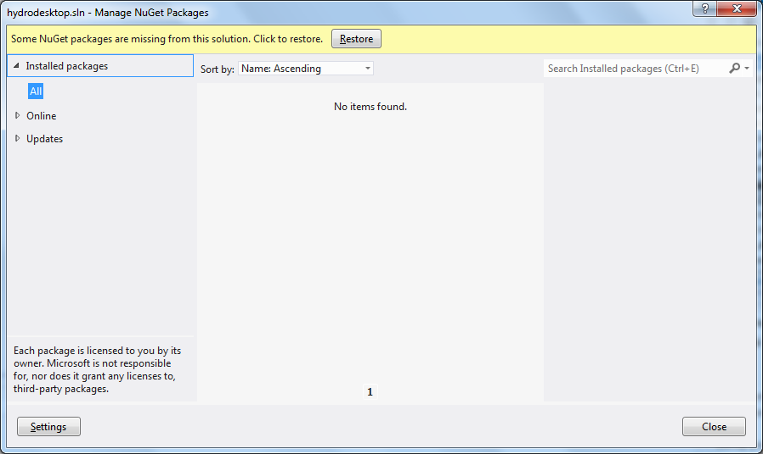

A message Some NuGet packages are missing from this solution. Click to restore is displayed. Click **Restore**.The missing library packages will be downloaded from the NuGet.org and MyGet.org websites. This may take a few minutes.

**Workaround: error message** Note: If you see a message saying: **an error occurred when trying to restore packages. Please try again**. The do the following steps:

In the current Manage NuGet packages window, select **Installed Packages**

For each of the packages (for example DotSpatial.Controls), select the package and click **Manage** and click **OK**.

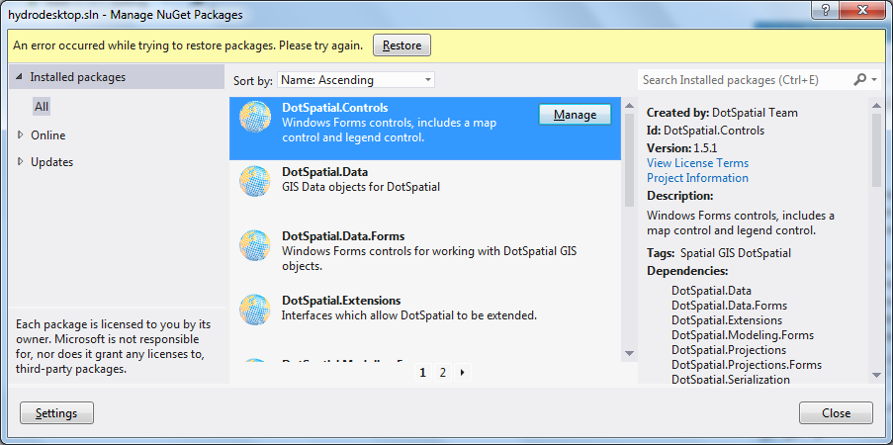

Close the Manage nuget packages window

In Solution Explorer, Right click on solution HydroDesktop and select **Build Solution**.

Note: If the build shows errors, select **Rebuild Solution**

# Step 4 Run HydroDesktop

In **Solution Explorer,** Right click on HydroDesktop.MainApplication and select **Set up as startup project**.

**Click Debug (F5)**

**This will run the latest version of HydroDesktop**

